ACSM ROUNDTABLE
GLOBALIZING EXERCISE IS MEDICINE®:
SCIENCE, PRACTICE, AND POLICY LANDSCAPE

INTRODUCTION

A large number of people are sedentary, and that number is increasing as more people worldwide are living in urban settings. Diseases of the developed world, such as cardiovascular disease and diabetes, are increasing worldwide at a rapid rate. Indeed, the WHO states that chronic disease (i.e., noncommunicable disease) is now the major cause of death and disability worldwide. A handful of risk factors, including high cholesterol, hypertension, and obesity, cause the majority of chronic disease burden. A change in PA would have a major impact on eliminating these risk factors and reducing chronic disease.

Exercise Is Medicine calls upon physicians to assess and review every patient’s physical activity program at every visit. But it is not enough to ask this of physicians. We need to provide practical solutions in terms of implementing successful physician counseling and referral programs. An enormous amount of evidence shows that exercise improves overall health and advances the health of patients with chronic diseases. Working from this evidence base, we will show outcomes and discuss what we would like to see happen with EIM.

EIM complements other global initiatives that address the prevention of chronic disease and the promotion of physical activity and healthy lifestyles. Primary care strategies for physical activity are central to the WHO Action Plan for Preventing Chronic Disease (http://www.who.int/nmh/publications/9789241597418/en/index.html),
WHO Global Strategy for Diet, Physical Activity and Health (http://www.who.int/mediacentre/news/releases/2004/wha3/en/index.html),
new CDC and NIH initiatives for building capacity for chronic disease prevention in low- and middle-income countries (LMIC) (http://www.nhlbi.nih.gov/about/globalhealth/alliance-chronic-diseases/index.htm),
and comparable capacity-building efforts from the non-governmental sector (Gates Foundation and Oxford Alliance). By 2020 80% of all deaths from chronic disease will be in developing countries (LMIC). The ability to effectively address this heavy disease burden will require effective strategies for PA promotion, especially within the primary care networks that form the core of the health care systems in most low- and middle-income countries (LMIC). EIM could be a key part of this shift in global health.

R .

Figure 1: Program Elements of Exercise is Medicine
Area 1. | Make available tools, training, and referral mechanisms for physicians and other health care providers.
Area 2. | Strengthen the science and evidence for the efficacy of exercise prescription in health­care settings.
Area 3. | Pursue policy interventions that support Exercise is Medicine™.
Area 4. | Stage patient advocacy and marketing campaigns
Area 5. | Build coalitions and partnerships.
Area 6. | Identify, develop, and disseminate "what works" models for patients as well as entire communities.
Area 7. | Create a Web site with strategy, content, and functions that support all the program elements of Exercise Is Medicine

SECTION 1: SCIENCE

A central goal of EIM is to encourage physicians and others in primary care settings to promote and recommend exercise to their patients and clients. This goal can be achieved through health care professionals directly prescribing exercise, or through PA referrals from primary care providers. The idea is to bridge the gap between clinical specialists and physical activity specialists in order to increase activity level among all patients.

In this section we discuss the scientific evidence relevant to EIM. We know there is overwhelming evidence that exercise improves overall health. But the research literature on PA prescription and referral is relatively new. The literature that does exist shows modest improvements in PA behavior in the target audience that receives advice from physicians to be more active. We need to identify the tools and strategies that will help physicians effect sustained PA behavior change in their patients in order to improve health. As the literature on PA referral grows, we must carefully evaluate as we proceed and identify best practices.

Evidence For Physical Activity Interventions In Primary Care With A Referral Component

There are clear advantages to having GPs and primary care physicians promote PA in their practices: large proportions of the population attend primary care each year, and patients see providers as credible sources of health advice and hence patients may be receptive to exercise information. The type of health care system in which a physician practices will strongly affect the kind of advice or PA intervention that they can deliver. For example, one must consider the reimbursement schedules for clinicians, especially for preventive counseling. In addition, PA advice in clinical settings may target prevention at several levels: primordial, primary, secondary, or tertiary prevention (see FIGURE 1). Exercise-promoting roles exist for clinicians across the prevention spectrum, beginning with advocating for preventive health (primordial prevention). Clinicians should ask about physical activity of all new patients (primary prevention), and especially among those at high risk of chronic disease (secondary prevention). Among those with established cardiovascular disease, diabetes, and many other chronic conditions, exercise prescription may be a beneficial component of therapy but will require medical clearance and ongoing support.

FIGURE 2: Levels of Prevention

Levels of Prevention
PRIMARY
PREVENTION
prevent disease
well before it
Develops
Reduce risk factors
SECONDARY
PREVENTION
early detection of
disease
[eg. Screening &
Intervention for
Pre diabetes ]
TERTIARY
PREVENTION
treat established
disease
to prevent
deterioration

Whole population, selected groups and healthy individuals
Selected individuals with high risk; patients
Patients
PRIMORDIAL
PREVENTION
establish or
maintain conditions
to minimise hazards
to health
Whole population, through public health policy
Primary care
advice as part of routine consultation
e.,g, primary care Risk factor reduction for those at risk of chronic disease, falls, injury
e.g. exercise advice as part of cardiac rehabilitation
Advocacy for social change to make physical activity easier

Barriers in attempting to influence physicians:
•Physicians say they haven’t got time to add PA counseling to their patient interactions
•PA is not a drug, and in medicine there is an emphasis and training on prescribing mostly pharmacologic therapy
•Physicians report a lack of interest and/or confidence in PA counseling
•They report some frustration that the PA experts keep changing the PA “message”—i.e., volume, type of activity, active living vs. sitting time (keep in mind that changing the message every 10 years is a lot for a physician trying to keep up with best practices in a broad spectrum of diseases).

Range of Intervention in Primary Care:

1) Interventions that the clinician or someone in the practice setting can deliver:
•Provide brief verbal advice encouraging “everyday” activity at recommended levels of PA
•Supply written PA prescriptions (tailored individualized guidance to patients on type, frequency, intensity, or setting for PA)
•Distribute patient information brochures, leaflets, self-help booklets about ‘how to get more active’
•Offer structured counseling, goal-setting (more detailed than brief advice)
•Refer patients to structured advice/counseling +/- structured programs

2) Interventions that other professionals can provide in the clinical setting:
•Counseling by a practice nurse or exercise scientist within the clinic
•Provide follow-up either face-to-face, by telephone, or by mail
•Refer to other facilities, PA programs
•Supervise exercise programs

FIGURE 3: Possible Pathways of Exercise Counseling And Referral. We note that there is no clear international definition for “exercise referral”. We view the physician as the gatekeeper, the one who could provide the initial counseling him- or herself, and/or then undertake exercise referral to facilities or programs outside the practice setting.

What Are Physicians Doing About PA Counseling In Routine Practice?
In this section, we will explore the following questions:
1) How many family physicians advise about PA routinely?
2) What is the effect of primary care counseling?
3) What are the effects of referral schemes (mostly by examples)?
4) What is the generalizability of the evidence?

How many doctors advise about PA? How often do they advise or recommend PA, and how long do they spend in PA counseling? In a 2007 study in Australia, Buffart et al. found that 53% of GPs report discussing PA with greater than 10 patients per week (up from 43% in 1997), and 92% feel GPs should be active role models for their patients (up from 76% in 1997). However, only 31% asked new patients about PA-- far fewer than asked new patients about their smoking status.

In a US study in 1998, 52% of the study population said that their physician asked them about PA, especially if they were obese or sick. Importantly, patients who were asked about PA were 1.7 times (CI=1.5-2.0) more likely to engage in the recommended PA.

In a Canadian study of 330 family doctors, half of the doctors believed that one-quarter of their patients would respond to PA counseling (Kennedy et al.). Yet surprisingly, only one-twelfth counseled “most patients” about exercise. Forty percent of the physicians felt moderately knowledgeable to counsel. They felt that the main barriers to PA counseling were a lack of time and lack of training.

Other studies have yielded similar results. Only a quarter of older patients recall their physician ever mentioning exercise (Bauman 1999; Tate 2001).

Based on these findings, we conclude that primary care physicians still are not asking their patients about PA very much, and these questions/counseling are not “routinized” in any way.

A Review of PA Interventions In Primary Care Settings: Do They Work?

The research literature on PA interventions has focused mainly on ‘brief advice’ interventions delivered by a physician, with far fewer studies on exercise referrals and community-based programs. Hillsdon published a randomized controlled trial (RCT) in which he recruited 45- to 64-year old sedentary adults in primary care. Patients were sent a questionnaire and randomized into one of three groups: those receiving direct advice, those experiencing a brief negotiation, and true controls. He found no significant difference in percent change in PA between interventions and controls at 12-month follow-up.

Simons-Morton conducted a well-designed study in the US called The Activity Counseling Trial. He objectively measured how PA benefited cardiac fitness and found that two extended counseling protocols were better than advice alone in a primary care setting. Results persisted for 24 months. In another US study, entitled Patient-Centered Assessment and Counseling for Exercise and Nutrition (PACE), researchers looked at the effect of three conditions: advice/counseling by a physician; health education materials and exercise prescription; or follow-up phone call from a health educator. They validated their results using a Caltrac accelerometer. Results from the PACE study were not quite significant. A PACE study in the Netherlands that consisted of a RCT of 350 subjects found that both the intervention and control groups improved over time, but there was no significant difference between them.

A study by Halbert et al. looked at the effect of an exercise specialist embedded within a clinical practice. In their study, an exercise specialist provided advice to patients with cardiovascular risk factors in an Australian general practice setting. They found this approach to be effective.

A study in the US examined the effect of a telephone counseling intervention. One physician in one family practice in Puget Sound participated. Inactive patients received three sessions of telephone counseling, 30 minutes each, from a health counselor. The researchers found that the PACE score was higher in the intervention group, but that this difference was not significant

In 2002, Smith et al. summarized all the literature on PA counseling in “Evidence for effectiveness of PA compared to other GP interventions.” They report that smoking advice from a physician results in about 5% quit rates, alcohol advice yields approximately 10-14% quit rates, and nutrition advice results in a 5-8% change. PA advice yields about 10% change. These modest effects tend to be short-term, with limited evidence of longer-term effects. They conclude that investment in PA counseling in the primary care setting has the potential for population-level health gains.

The “Green Prescription” in New Zealand
In New Zealand, they got it “more right”—they developed and trialled the so-called green prescription, in which physicians “prescribe” PA for their patients. A number of studies have assessed the efficacy of this kind of program. In the Australian Active Practice I Project from 1998, Smith et al. looked at 1,142 adults aged 25-65 years old from 27 different general practices (55 GPs participated). They compared two brief interventions with routine care: Exercise Rx (brief PA advice) versus the PA Rx plus informational booklets (FIGURE 4). They measured PA change at 6-8 weeks and 7-8 months. They found the greatest PA change with prescription and booklets combined.

In New Zealand, two trials provided an evidence base for the green prescription. Raina Elley et al. conducted a study entitled “Effectiveness of counseling patients on PA in general practice: cluster randomized controlled trial.” They worked with middle-aged patients from 46 GPs in New Zealand. They hybridized green prescriptions and exercise scientists giving telephone advice. When they looked at mean change in PA at 12 months, they found that change was significant in the intervention group and negligible in controls.

FIGURE 4: New Zealand resources – The Green Prescription.

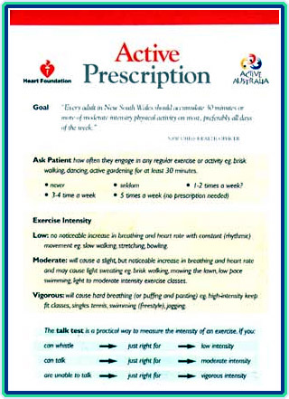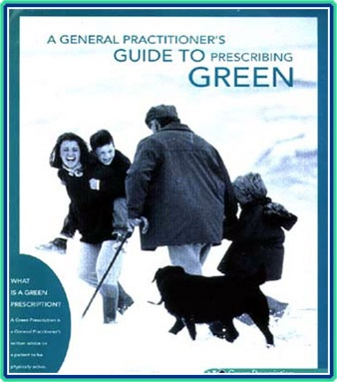
Examples of resources for Doctors
The translation component of the Green Prescription program involved partnering with the New Zealand National Sports and Recreation Agency (SPARC) (FIGURE 5). They linked primary care with referrals to sports/exercise facilities in communities across the country. The doctor served as the gatekeeper who asked the patient about PA. Patients considered “insufficiently active” were given a written or electronic green Rx and were referred to Regional Sports Trusts (community-based exercise and sports programs) where they could choose from a vast range of exercise/sports programs. A patient support person in the Sports Trust followed up with monthly telephone calls, and the patient returned to the clinician after three-to-four months for review.

The highly-successful Green Prescription program in New Zealand consisted of a whole system for PA implementation and maintenance. The primary care physician served as the gatekeeper who assessed the patient and referred him or her to sports and exercise programs. The patient received ongoing support through the program, and the process regularly looped back to the physician. It worked very well for about ten years, until it was moved from the sports ministry to the health ministry.

FIGURE 5: How Green Prescription Works.

SUMMARIES/CONCLUSIONS:

Summary of Systematic Review of the Effectiveness of Interventions
•Mostly brief interventions in clinical setting have short-term impact on PA
•Increases in PA were modest, and not to the recommended levels of 2.5 hours per week
•Primary care is part of the public health solution, but reach is low (few physicians ask about physical activity levels, or counsel patients regularly)
•Intensive interventions are not better than brief interventions
•Results are better if you target a single risk factor at a time
•Results are better if you target those who are inactive and try to achieve small increases in PA

Effectiveness Summary:
•Most studies have tested brief interventions such as 3-5 min. counseling sessions
•Outcomes are better if PA regimens are individually-tailored and goals are set; and if staff provide follow-up via mail or phone
•Multi-component interventions that combine provider advice with behavioral approaches are promising

Common Features of Interventions Which Achieved Sustained High Participation
- Home-based programmes
- Unsupervised informal exercise
- Frequent professional contact
- Walking as the promoted exercise
- Moderate intensity exercise

However the evidence base is far from definitive. The US Preventive Services Task Force (USPSTF) concluded that the evidence was insufficient to recommend for or against behavioral counseling in primary care settings to promote PA. They cite as their reasons:
•Insufficient evidence to determine if counseling in primary care to promote PA leads to sustained change
•Mixed results in controlled trials of PA counseling for adults in primary care
•Limited data for children and adolescents
•Limited data on feasibility and generalizability

Exercise Referral Programs – The Evidence

Exercise referral programs are those where the primary care setting is a gatekeeper, and patients are referred to programs and facilities outside the practice. These programs have been developed in different countries, using different models: in some countries these programs are public or free, and in other regions they are mostly privately run. The accreditation, reach, and population targeting of these referral programs differs among countries.

In the United Kingdom, exercise referral programs are organized around municipalities, and there are lots in Europe as well. Typically, a physician refers the patient to a community leisure center for 12-14 weeks of group exercise. These activities are organized geographically around municipalities. Similar referral programs are frequently reported in Europe. Examples are shown in FIGURE 6:.

FIGURE 6: Exercise Referral Program Effects. This table summarizes some major studies, and the main outcomes of each.
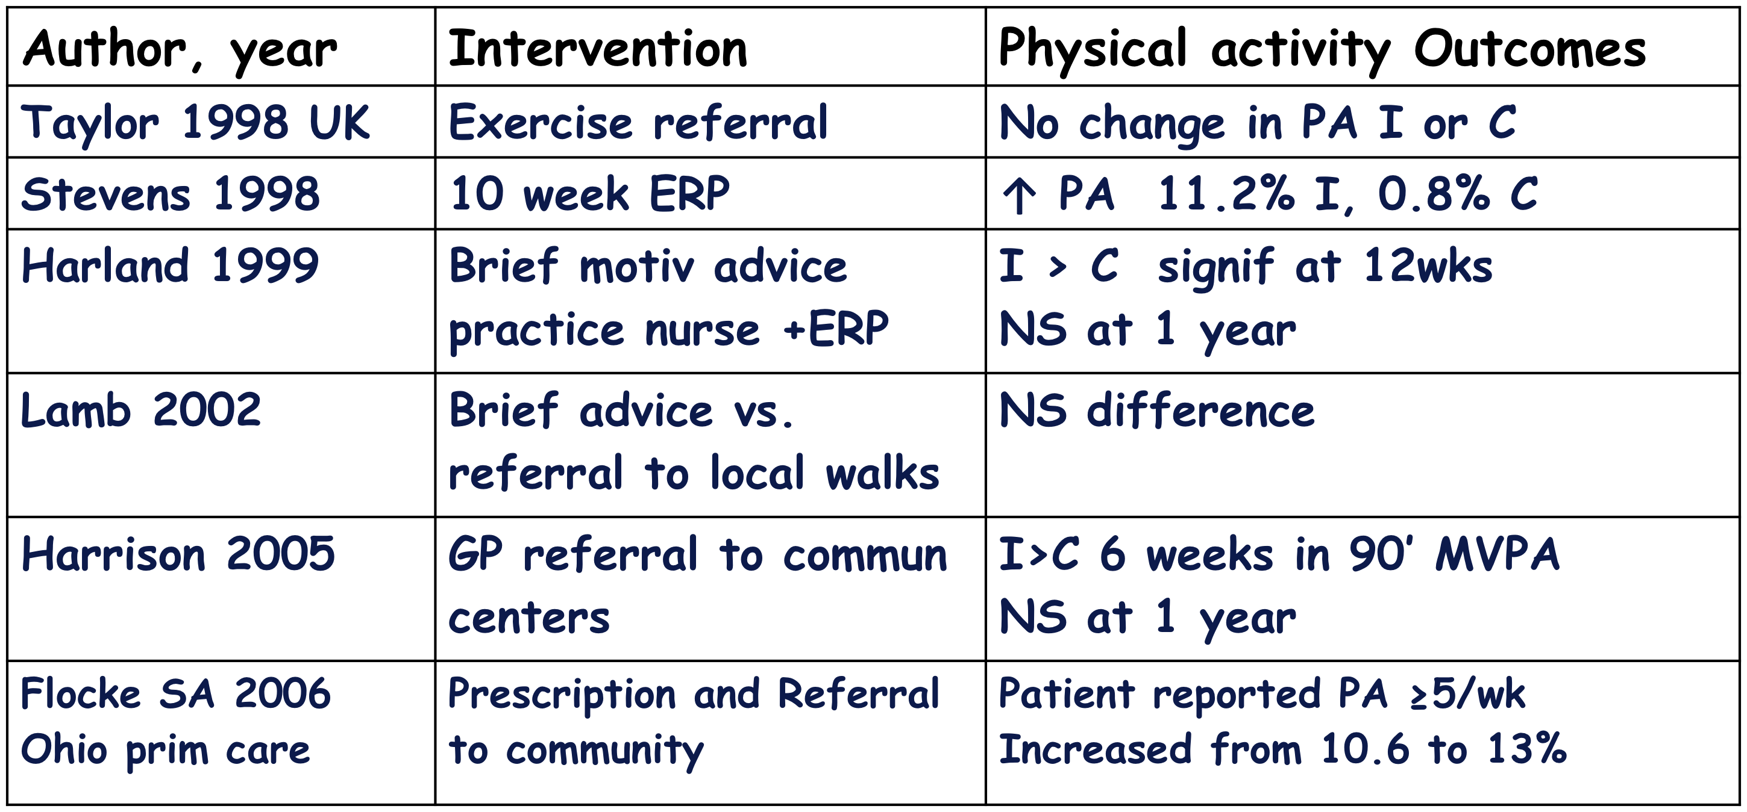
Exercise referral program effects

In Denmark in 2008, a small RCT by Sorensen compared an exercise prescription (patients prescribed/referred by clinic to an exercise program) to low-intensity advice. They found no significant difference in VO2 max at follow-up.

The thorough 2007 Exert Study by Isaacs involved 900 inactive patients aged 40-74 in a 3-way RCT: (i) 10-week, center-based exercise, (ii) 10-week community walking program, or (iii) practitioner advice only. At six months, they found that the percent change in people achieving at least 150 minutes per week of PA was 13.8%, 11.1%, and 7.5% respectively. The effects of the exercise referral program at 6-month and 12-month follow-up were comparable to community walking programs. The state of change (SOC) increased most in the walking group.

Systematic Reviews and Meta-Analyses of These Studies
As of yet, there are very few RCTs on exercise referral programs (ERPs). However, one researcher has pooled the results across exercise referral studies. While each individual study is non-significant, the trend in the meta-analysis by Williams (2007) favors the intervention group, indicating that people do become more active with exercise referral. Williams et al. meta-analyzed 5 of the 6 existing RCTs in the field. They compared exercise referral schemes to controls according to the proportion of participants who took moderate exercise and found a 20% increase in the sedentary-to-moderately-active group. This form of analysis is an elegant way to show that the effects are small but worthwhile. At present, there are almost as many reviews of exercise referrals as there are RCTs themselves, indicating an intense interest in this field and the acute need for more quality research.

Other studies examined the population uptake of exercise referral, and attitudes towards these programs. In the Reach study in the Netherlands in 2008, Schmidt found that mid-aged minority women liked ERPs because they saw them as a supportive environment for PA. They felt exercise should be convenient and culturally-tailored.

In northern England in 2005, Dugdill sought to ascertain who attends these referral programs. He reviewed two ERPs. He found that three-quarters of patients were referred by physicians and one-quarter from practice nurses. There was 30-40% adherence among patients. These patients consisted largely of diabetics and cardiac rehabilitation patients. Among those who completed the program, there were modest improvements in measures such as BMI, blood pressure, and minutes-per-week in PA.
At present, there are almost as many reviews of exercise referrals as there are RCTs themselves, indicating an intense interest in this field and the acute need for more quality research.
In Harrison’s 2005 study, a region in England was reviewed from 1992-2002 in order to ascertain the “reach” of ERPs. He counted 1,200 referrals per year, which represented 4% of sedentary adults. He found that 79% attended their first appointment, and that two-thirds of the patients had cardiovascular disease or musculoskeletal disorders. He concluded that exercise referral schemes were unlikely to impact population PA levels due to low reach.

The perceptions of ERPs by health professionals was the subject of a 2005 study by Graham. His findings indicate that referrals are non-systematic and that health professionals believe that most patients ignore advice. They also believe that PA promotion advice is only a priority for those with chronic disease. In Sweden, Liejon reviewed a regional ERP. He gathered data from 8% of a county, which consisted of 6,300 ERP referrals, mostly for walking programs. Most of the patients referred had CVD, type 2 diabetes, musculoskeletal disorders, or were obese.

A 2005 UK study by Sowden examined the use of ERPs by socioeconomic status (SES). He found that GPs from disadvantaged regions were more likely to send their patients to exercise programs. He further discovered that disadvantaged female patients were just as likely to utilize ERPs as their advantaged counterparts.

Points of Discussion concerning the issues raised:

•We need to do a better job in medical education at all levels of a physician’s training. The message should be simple and clear, and delivered to all patients: take 150 minutes a week of walking in at least 10-minute bouts. Focus on target heart rate. Don’t make the message more complicated than it needs to be.

•Capitalize on modern technology: Put programs in place that utilize devices such as iPhones, iPods, PDAs, etc. in order to reach tens or hundreds of thousands, even millions of people. King performed a study on people over 50 years old, 90% of whom had never used a PDA. The treatment, which involved text messaging, seemed to work to increase PA, and 80% of participants liked the PDAs! If this technology works in an older cohort, it will certainly have success with a younger group, and the cost is relatively low.

•There is evidence that exercise referral programs are moderately effective, but there may be some problems with accreditation of programs, and in some countries there may be a need to regulate this complex industry. In the US, we currently have over 500 organizations with certified exercise programs, many of which have dubious credentials. We can’t ask physicians to refer to programs unless they have confidence in them.

•No single group can create population-level PA change on their own. There must be a system in place that begins with the physician, includes other people and groups, and links back to the physician. While some of us feel the best adherence occurs when patients are referred by their physician to programs in the community (as is the case in New Zealand), others feel patients do best with a person who provides motivation, due to the greater emphasis on behavior modification.

•If you deliver a program effectively, there are cost-savings. Therefore it is critical to know what population reach we are achieving when we broadly disseminate a program.

•It can be difficult for a physician to determine the activity level of a patient. Some physicians use 150 minutes/week as a cutoff, using physician questioning or patient self-report. Many like to recommend pedometers to their patients because they provide some objective measure of activity that does not rely on patient report/recall. In addition, the physician’s own activity level may influence his or her determination of a patient as adequately active, and may affect whether or not s/he feels it is important to counsel and refer concerning PA.

SECTION 2: PRACTICE
The way in which a given country defines terms such as counseling, referral, and risk vary. Who will be the provider, and who will pay them? The answers to such questions may vary even within a country. We seek here to provide general guidance on key issues, and examples of working models from different countries. Our desired outcome is to facilitate population-level shift in PA behavior through activities of daily living.

Who Are The Health Professionals?
“Health professional” is a broad term, the specifics of which will vary from country to country. It may include general practitioners, physician assistants, nurses, nurse assistants, nurse practitioners, physiotherapists, nutritionists, and other health promoters in a clinical setting. It should be noted that while health professionals may know a great deal about health, they likely know very little about PA. Similarly, there are those who know less about health, but a great deal about PA, such as physical educators, gym trainers, fitness professionals, etc. For the sake of our discussions here we view the primary care physician as the gateway to PA counseling and referral, but we recognize that in some settings other health professionals may play that role.

Creating Physician-Led Teams

A common theme in many places is the idea of the primary care “team”, which treats the patient as a whole and combines social and medical aspects. In much of the world, particularly low- and middle-income countries (LMIC), a majority of the population receives basic health care in public community primary care centers. These primary care networks traditionally have focused on maternal and child health, vaccinations, and the treatment of infectious diseases. However, with the growing global burden of chronic diseases, primary prevention of heart disease and cancer, and treatment of conditions such as diabetes and high blood pressure, are becoming part of the work performed by these clinics.

For example, in Brazil there are physician-led teams performing community outreach, and PA experts are being inserted into these teams. The Ministry of Health has funded more than 1500 primary care clinics across the country to begin primary prevention programs for chronic disease. These programs involve screening, counseling, and treatment within the clinic in addition to outreach to communities. Multi-disciplinary teams including physicians, nurses, nutritionists, psychologists, and social workers deliver care in the clinic and community. In several states, physical activity professionals have been added to these teams to counsel patients and lead community physical activity classes or programs. Evaluation of this model in the city of Recife in the Northeast of Brazil suggests that this approach is effective in increasing community levels of physical activity.

In Canada, each province oversees the medical system. Physicians are paid based on the number of patients they see each day. As such, in order to implement EIM into the Canadian provincial medical system, the physician would need to feel comfortable with the documentation of prescribing exercise so that they do not feel encumbered by the extra time it takes to talk about how exercise can improve health. Somewhat similar to Brazil, many medical clinics operate with several physicians working in the clinics. A PA expert could fit nicely into the EIM/medical/pay per patient system. A PA expert could be employed or contracted at a clinic to see patients after their visit with the physician to discuss with the patient the benefits of exercise and how to start an exercise program. However, an overriding question for the Canadian medical system is how the PA expert would be paid. With many provincial health care systems struggling with money, there may not be enough money for the PA experts to be paid by the government medical system. This situation then leads to the question of who will pay for the exercise prescription. In other situations physicians have private offices that are usually in “medical” buildings. A PA expert could approach physicians to collaborate relating to EIM.

In the US, an example in the medical community of a primary care “team” is the Patient Centered Medical Home (PCMH) movement. Principles of this movement include: an ongoing relationship between a patient and a physician who leads a team of mid-level providers (medical assistants, physician assistants, nurse practitioners, etc); coordinated and integrated care of the whole person; and patients and their families participating in evidence-based decision-making. Payers provide an expanded level of care within the primary setting. The goal is to efficiently deliver care that translates into changes in patient behavior. PA promotion occurs within the PCMH. We could learn from, and in the US perhaps partner with, this movement.

Although models will differ across countries, many core principles are the same, such as including a PA expert in a primary care team and exploring ways in which EIM can integrate into these settings. Synergies between physicians and PA professionals take effort, investment of time and money, and leaders who take ownership of the project.

Health Professional Referrals
There are many ways to define referral. One person may define it as a shifting of responsibility for the patient from one person to another, while another definition views it as the inclusion of another professional who supports the patient. A physician can refer to a person, a program, or internet-based resources, for example, both within the practice and out in the community. Others feel that the term “referral” may be inappropriate in the same way that “exercise prescription” may be inappropriate—because for some patients, it may imply that the cost is completely covered.

There are many possible ways in which the referral process may occur. We provide here one example from Columbia (FIGURE 7):

FIGURE 7: PA Referral in Colombia. Flow chart showing the way decisions are made concerning a patients PA referral.
Current PA referral system in Colombia
Risk Factors
(Enter Gate)
General Practitioner
Medical Specialist
NO
YES
PA Professional
Physical Therapy
Therapist/ MD
Ostheomuscular< Trauma
Post operative recovery
Rheumatic disease
Muscular illness
Low back pain
Cardiovascular Rehabilitation
Respiratory rehabilitation
Coronary heart Disease
Cardiac Failure
Hypertension
Stroke
Obesity
Diabetes
COPD
Pulmonary hypertension
Asthma
Sleep apnea/Obesity
Interstitial Lung disease
Health Professional
Primary care

Referral Determinants
•PATIENT: Knowledge of the health system and disease/risk factors, personal needs, attitudes, and formal request (Empowerment).

•DOCTORS: Knowledge of the disease/risk factors and health system, attitudes, training, counseling skills, reimbursement, system limitations and adverse occupational incentives (e.g., physicians will spend the time/money that their boss asks them to spend. They cannot spend more)

•HEALTH SYSTEM: Resources (trained professionals; time and cost limitations), information/communication to patients and health professionals, standards of care/guidelines, and lack of a systematic process.

We note that while in some countries, clinical evaluation forms/insurance forms used by physicians have questions about physical activity level, it does not necessarily mean a physician asks the questions, nor does it mean he alters his interactions with the patient based on the patient’s response.

How Do We Screen Patients?
How one goes about screening patients for participation in PA is a complex social and economic problem. Collaboration between physicians and PA professionals is critical, but requires time and effort. Although screening is extremely important, we must be careful not to erect roadblocks in engaging people in safe PA. While we want to be mindful of screening, we also do not want to “over-medicalize”. Our goal is population-level shift in activities of daily living, such as getting people off their sofas and out walking.

A person with chronic disease such as congestive heart failure will need a PA professional trained in exercise within the context of chronic disease. These patients often have many co-morbidities, including major depression and anxiety that may present barriers to behavior change concerning PA. Such patients may respond best to health professionals who have the time to understand their emotional needs, if the economic structure allows. However, even with those experiencing chronic disease, the barriers to PA often are similar to those without PA (e.g., perceived lack of time, complexity of schedule, etc).

We recognize that a large percentage of the general population may have hidden risk (poorly-controlled hypertension, dyslipidemia, etc). It is important to objectively define a person who needs monitoring. Possible ways to evaluate risk may include exercise tests, EKGs, bp, cholesterol levels, BMI, and health questionnaires to assess diet and exercise.

However our Australian colleagues have observed that even the highest risk patients are not dying at a greater rate with PA than without. Therefore, they have moved from screening to the idea of “streaming” a patient into the right PA program. They once viewed an adverse outcome as death, but their data do not support this fear. Now they see an adverse outcome as a patient being less likely to implement or maintain PA, perhaps because they were referred to the wrong type of PA professional or program. Therefore one strategy might be to screen people for barriers to PA behavior change in order to stream them into a PA program with the highest likelihood of success for them.

The Medical Certificate in Italy: A Medical Screening Success Story
In Italy from 1975-1982, 3.6 athletes per 100,000 died annually from sudden cardiac death (SCD). The media attention these deaths received prompted the creation of a medical certificate program.

SCD is defined as a non-traumatic, nonviolent, unexpected natural death of cardiac origin occurring within one hour of the onset of symptoms in a person who does not have a previously-recognized, fatal cardiovascular condition. It does not include trauma or accidents. Causes include hypertrophic cardiomyopathy, coronary artery disease, arrhythmogenic right ventricular dysplasia, congenital coronary anomalies, valvular heart disease (mitral valve prolapse, aortic stenosis), dilated cardiomyopathy, aortic pathology (acute rupture and dissection), long QT syndrome, and Brugada syndrome.

Since 1982, in order to prevent sudden death during competition, the Italian law has required athletes (about 7 million people) to undergo annual medical exams to obtain a medical certificate for participation in sports activities. The certificate is specific to each sport, given the different risks during training and competition relative to a given sport. An “athlete” is associated with the Italian National Olympic Committee (CONI). Athletes as young as seven years old (as well as elderly athletes) are evaluated. Examinations occur at an ambulatory Sports Medicine Center reserved for athletes. A physician in sports medicine (five years of specialization after the MD degree) conducts a compulsory complete exam including urine test, respiratory function (spirology), vision test, and hearing test. They also use a 12-lead EKG at rest and during a step test or bike ergometer test.

Athletes with a disability (e.g., para- or quadriplegic, cerebral palsy, blindness, deafness, amputation, etc.) follow a similar exam using an appropriate (cut arm) ergometer during a stress test. Professional athletes follow a completely different medical regulation.

For non-athletes, i.e. the general population (about 16 million people), the law requires a different annual exam to obtain a certificate to participate in sports activities such as attending a gym or playing soccer on a Sunday morning. Only a clinical exam with resting EKG is required.

If a life-risking disease is found during the exam, a certificate is denied. This outcome occurs in 5% of first exams, and 1.3% of exams in subsequent years. Additional medical tests may be required, such as ECG, cardiac stress test to exhaustion, holter monitor, prescription medications, NMR (MRI), etc. These tests are provided almost free of charge by the National Health System. About 18% of the entire population require additional evaluation. For athletes under age 18 and for the disabled, the certificate is free. For others, the cost ranges from $40-$80 Euro (about $48-$96 US).

Twenty years after the inception of this certification program, a publication in JAMA showed that SCDs in athletes had dropped from 3.6 per 100,000 annually to almost nothing. For 23 million Italians, this program provides a high level of protection, significantly prevents disease, and reduces the frequency of hospitalizations. We know of no other country that has yet instituted such a program.

Evaluating The PA Professional/Program

A health professional must be able to refer with confidence. ACSM is in the process of developing a verification program for all fitness professionals (i.e., including non-ACSM certified professionals) qualified to receive referrals from physicians. This program would allow a physician to refer to a qualified fitness professional with a click of a mouse. Included within this verification program is a modification to the physician clearance process that would streamline the medical clearance process for those at low risk for exercise-induced complications.

Another area of concern is lack of behavior change emphasis in the fitness professional/client interaction or in the training model that has been the standard for the industry for many years. There has been a significant trend toward trainers emphasizing lasting behavior change in their interactions with clients. This trend is evidenced by the rapid growth of both the wellness and fitness coaching fields as well as the significant behavioral emphasis added to the revisions of the ACSM certifications (to 20-25% of the knowledge and skills of the examination content).

ACSM also encourages fitness professionals to consider other business models for providing training services to clients. Instead of exclusively offering ongoing/long-term training packages, ACSM supports the inclusion of training plans for more moderate-income clients that would provide options from as little as one visit to up to ten visits, spread over as much as six months. This approach gives those with more limited income access to the benefits of professional support. Additionally, the Exercise is Medicine program is developing no-cost interactive web support services for those who may never hire professional trainer support services.

How Do We Partner With Physicians?
The core responsibility of a physician is to promote health. Many physicians are aware that it’s important to counsel patients about PA, but most do not know how. They need to be taught how to conduct brief, effective patient counseling using strategies such as motivational interviewing. Behavioral scientists have taught us that a 3-5 minute interview can be highly effective if the physician is trained to convey a convincing attitude and to use his voice and eye contact effectively. The interview should emphasize practical advice tailored to the patient, complete with examples.

We can work to include PA assessment, counseling, and referral at all levels of a physician’s education and training. In the US, if one can get questions concerning PA on medical board exams (both general and specialty boards), the content area is likely to find its way into the medical school curriculum. American medical students seem eager to do electives with primary care physicians in sports medicine, so perhaps those opportunities could be expanded. During family practice residencies, it is required to do electives in sports medicine. That requirement could be extended to other primary care residencies. In the US, the NHLBI/NIH provides grants to medical schools that want to develop curriculum in nutrition, which is arguably a more complex topic than PA; We might learn from this model and work in the US to get federal funding for medical schools who want to develop PA curriculum.

Physicians themselves can be encouraged to work to include PA in their education and practices. Medical students can request PA counseling in their curriculum. Physicians at all levels of training can model PA behavior and educate patients and colleagues, help create and lead school and community-based programs, and advocate for policy change within their institutions or at the regional or national level. They can raise awareness and funding for PA, and most importantly include PA counseling and referral in their practices. The point was raised that in some countries, physicians themselves are typically inactive and many still smoke, which may constitute a barrier to their ability to embrace the importance of PA referral.

In Australia, our colleagues achieved tie-in with physicians by implementing PA information into the training and guidelines for general practitioners. While this approach increased whether GPs thought PA was important, it did not alter the way the GPs practiced medicine. In the end, the training programs that succeeded in getting GPs to counsel their patients about PA were the ones that had them do rotations with exercise physiologists, dieticians, etc. Participation in PA-related medical rotations did increase the likelihood that GPs went on to include PA counseling in their practices.

What Is The Cost, And Who Pays?
The cost and payment will vary tremendously from country to country, including how (or indeed if) payment occurs for services that fall outside face-to-face visits with a physician, such as coordination of care, ancillary providers, and community resources. The need for a given provider, the fee for that type of provider, and the possibilities for payment of that fee must be factored into a PA plan. For example, in Italy if you break your leg, you might see a (relatively expensive) PT for 2-3 months, then switch over to a (relatively inexpensive) PA professional to improve overall health and fitness. One also must consider that a given service may be administered best by a less-costly professional. For example, providers other than the physician may be better trained at understanding the social and mental aspects of patient care.

FIGURE 8: Matrix of Qualifications of Professionals and the Cost To Employ Them in PA. We attempt here to provide a way to conceptualize, in simple terms, the ideas we present. From country to country, the specific practitioners that could be plugged into these fields will vary, but the matrix itself is generalizable to all countries.
 | Low cost | Medium cost | High Cost
Clinically trained only
PA trained only

Clinically and PA trained (rare)

One way to reduce costs is to ask a provider to offer their services to a group, rather than one-on-one. This approach also capitalizes on peer-to-peer learning, which has been shown to be important for behavior change.
In Sweden, a strategy to get the national budget under control has been to get the population physically active. The hope is that increased PA will dramatically reduce health care costs.
The way in which a physician is evaluated and compensated also may come into play. For example, while in some countries physicians are paid based on their patients’ outcomes, in other countries a physician is paid per patient. Therefore if PA counseling increases time spent with a patient, a physician may see fewer patients and be compensated less. And it’s not just a question of time and money, but also availability—some places lack general and family practitioners. It is critical to focus on an approach that minimizes time demands on a physician, such as brief motivational counseling, and allows other professionals to provide additional information and services.

In Sweden, a strategy to get the national budget under control has been to get the population physically active. The hope is that increased PA will dramatically reduce health care costs.

“Major Players” In Synergies Between MDs And PA Professionals

Government Health Policies
Strength (S) Obesity Law, Diabetes Guidelines, PA Plan
Need (N): Monitor compliance, identify and correct legal / administrative barriers

Regional /Local Authorities
(S): Integration Capacity, Community adapted
(N): Motivation, priority, political benefit

Private Industry (Nutrition, Equipment, Pharma)
(S) Resources, Marketing Structure and Mentality
(N) Sponsoring PA Education, Resources, PA programs
(Coca Cola has helped enormously)
(Johnson and Johnson diabetes program, totally sponsored by them)

Media & Marketing (Newspaper, Radio, TV)
(S) Low cost, high audience
(N) Simple - Science based info

University/Research Institutes
(S) Basic Science & Education
(N) Curriculum, Environment Education, Certification, Evaluation

Academic/Professional Associations
(S) Leadership, accepted access to professionals
(N) Education, Certification, Evaluation

Insurance and Health System
(S) Infrastructure & Resources
(N) Awareness of PA as cost saving strategy

Health Institutions, Hospitals, Worksite
(S) Captured population, occupational/productivity benefits, awareness
(N) Health Promotion & Prevention emphasis

SECTION 3: POLICY

Critical Health Policy and Systems Issues For PA Promotion Through EIM:
A European Perspective

In Europe, there are indications that the general population expects physicians to address physical activity with their patients. However, most physicians do not routinely address PA. The question is, how does EIM make contact with physicians to help them do so? Language presents a profound barrier. In Europe there are 53 countries, only two of which speak English as the national language.

The National Medical Associations (NMAs) in Europe will be a key player in this process. They view ACSM as a prestigious organization and are very interested in their work. They have the opportunity to reach physicians. They also exert influence on the media and on policymakers.

The media also is interested in what ACSM has to say. One can imagine a headline in a European newspaper reading “The American College of Sports Medicine Now Promoting Exercise Is Medicine.” The NMAs influence the media, which in turn affect policymakers. The media also can influence patients themselves—if a patient asks a reluctant physician about EIM, he will become interested in it because he wants to be part of the trend.

National policymakers (politicians, private citizens who can influence decisions) are influenced by the media and by NMAs. They can set policy that directly affects patients. In turn, patients may advocate directly for policy change.

Given the important role played by the NMAs in Europe, one first priority task is to communicate with them. The NMAs would appreciate guidance from ACSM, which they then could adapt for their own uses. It also is important for us to communicate with the media about EIM.

Communication with NMAs should emphasize:
•Institutional credibility of ACSM
•Evidence presented according to the standards of the peer group
•Relevance for the medical profession
•Opportunities for national key persons to get involved
•Ability to tailor EIM and primary care strategies for PA to national context and needs

Communication with the media should emphasize:
•Institutional credibility
•Evidence presented with an adequate degree of complexity
•Relevance to population and economy
•Opportunities to contact international and national experts
•A “surprise factor”-- Support of PA promotion through sports medicine might be perceived as trivial, so involvement of the Surgeon General, the head of a cardiology group, etc. would add additional weight

How can we support National Medical Associations (NMAs) in establishing EIM?
•Provide rationale and examples of communication strategies with physicians and health professionals. Examples might include position papers, events, and publications about how to approach physicians concerning EIM that can be translated.

•Address key issues of physical activity promotion in primary care and provide examples of solutions.
•Explain the role of primary care and others in PA promotion, including sample books like that provided by the WHO.
•Show physicians they play an important role but are not alone.
•Present possibilities for referral to other structures.
•Describe how PA can be included in medical training and continuing education.
•Provide clear concepts and guidelines. We hear repeatedly from physicians that they would like simple and consistent messages to give their patients, such as a pyramid diagram or dose-response curve (see FIGURES 9 and 10 for examples).
•Explain to physicians the possible health risks of PA promotion.
•Reimbursement is a huge issue, and one that we have not covered here.
•Evaluation and quality assurance are important—physicians feel responsible to patients so they want to refer to competent people. A certification process can help physicians refer with confidence. There are examples from all over the world (such as the National Health Service in England, or the Leijon study in Sweden) of a national quality assurance framework.

FIGURES 9 and 10: Examples Of Materials That Physicians Can Use To Educate Patients. The messages are clear and easy to understand.

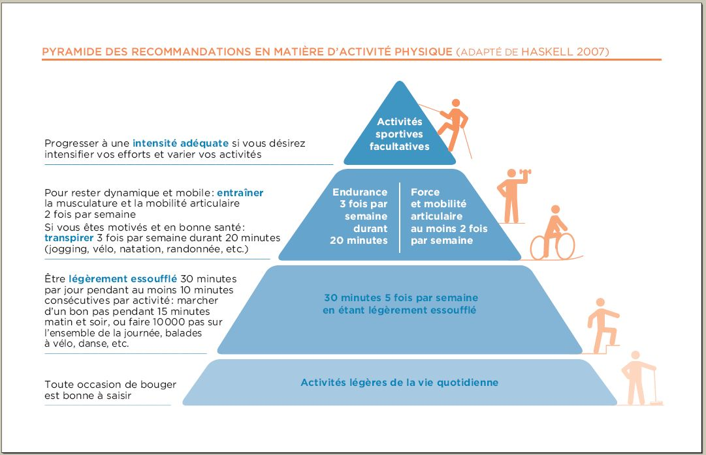
www.paprica.ch

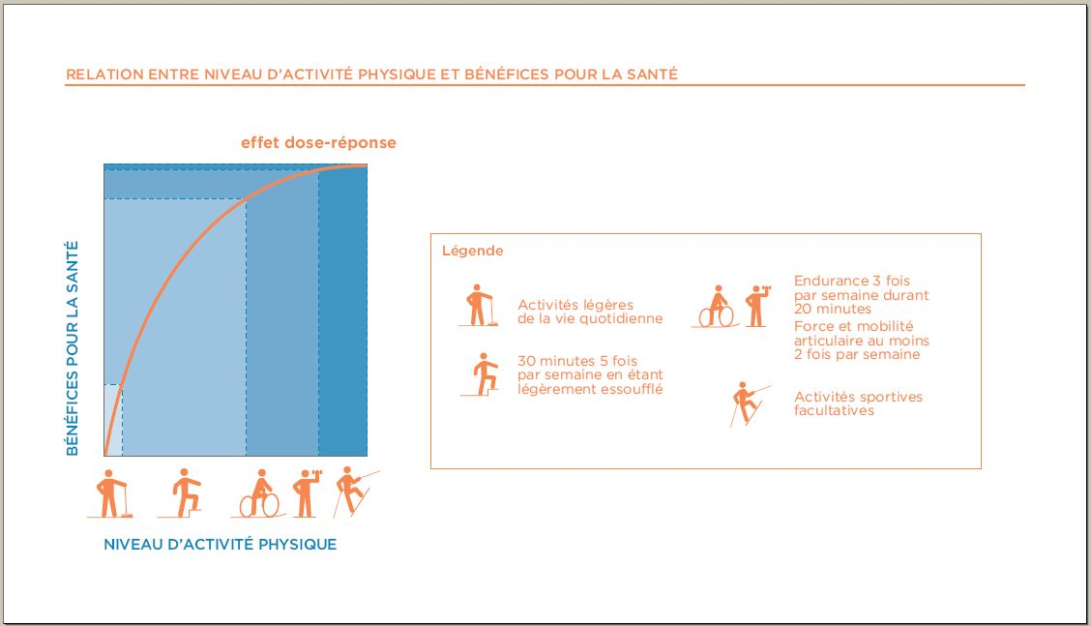
www.paprica.ch

How can we support NMAs to communicate with the media and policymakers?
Secondary tasks would include helping NMAs communicate with the media, and helping physicians communicate with policymakers.

•Provide examples of national adaptations of EIM informational material. One approach: take existing material and translate into many languages, or create documents in parallel.

•Provide contacts with groups and associations working in the field from different cultural backgrounds. Show examples in which the materials illustrate relevance for the local population and economy, examples of ways to link up with ongoing efforts in PA promotion, and examples of practical, policy-related solutions for thorny issues such as reimbursement.

•Create opportunities for sharing experience in communicating with the media and policymakers.

What Is The Common Ground Where We Can Collaborate To Effect Change?
It is helpful to hear views from different countries and exchange ideas, experiences, and suggestions. Here we identify the key policy messages common to all our countries.

KEY POLICY MESSAGES OF EIM:
- Engage Physicians. We want physicians to do PA assessment, counseling, and referrals. We want them to incorporate PA counseling as a core aspect of their practice.
- Profile The Evidence That Supports Exercise As A Therapy. Evidence-based medicine holds weight with physicians and is necessary, though perhaps not sufficient, to change their PA counseling behavior. Physicians realize that PA is good for their patients’ health, but they may not view exercise as medicine, therapy, or treatment for health conditions. In Australia there has been little success in PA for health promotion, but lots of success with the EIM movement, with currently 34 successful reimbursement negotiations for EIM when provided by accredited exercise physiologist (which hopefully translates into health promotion).
- Collaborate And Share Information. It will be useful for a group like this to continue to meet (in person and electronically) to exchange ideas and information. Such an exchange would allow us to keep updated on activities, forward documents to one another, etc. Longer term, we all may contribute important areas of work.
- Think From The Perspective of the People With Whom We Want To Work. If we are to influence policy, we need to view the issues from the perspective of policymakers and physicians, not just researchers. Target their language to change their behavior.

Other policy-related issues identified by the group:
•In terms of influencing policy, we need to show how big the problem is, and we need to provide a solution. The take-home message for policymakers is that inactivity is a significant risk factor for disease and premature death; and physicians must inform patients of risk and assess at every visit, where appropriate. It must become the worldwide standard of care to recommend 150 minutes per week of PA.

•Whether such recommendations change patient’s PA behavior, physicians have an ethical responsibility to inform patients. There is a moral imperative for physicians to inform their patients that goes beyond the evidence for behavior change.

•Everyone should influence policymakers—not just NMAs, but also physicians, PA professionals, health professional associations, consumer health associations, and patients.

•Emphasize that physician training and education simply involves strengthening education in motivational interviewing, and social and psychological skills.

•We already have strong evidence showing the role of PA in the prevention and treatment of disease. Research should focus on developing effective ways to influence behavior change in physicians and patients concerning PA.

•Currently, Australian and US insurance companies do not require that physicians recommend or refer for PA, in the same way they might require a physician to send a diabetic for an eye exam, for example. One target area might be to work at getting insurance companies to require PA counseling to get full reimbursement for treating patients with diabetes, hypertension, obesity, etc.

PA, Exercise, and Weight Loss
We must be careful not to use exercise and PA interchangeably, because they are not the same thing. In Mexico, our colleagues have tried to convince the government that PA and exercise are not the same. We should be extremely clear about what we are asking providers to do, and what we anticipate outcomes to be. We must agree on a common language and keep the message to policymakers simple. Indeed, exercise can be dangerous for some patients. But we are asking physicians to encourage patients to be active in activities of daily living. Also, PA is separate from weight loss. The desired outcome is not weight loss, it is increased PA for overall health (i.e., physical and psychological).

However, we recognize that PA fits into a comprehensive approach to health that must include weight management and nutrition education. There has been a continuous increase in weight of the population of the developed world, despite knowledge concerning PA and nutrition. We need new strategies to tackle these difficult problems. One possibility is to teach the importance of PA and nutrition at younger ages, in high school, middle school, or even younger.

How can EIM be implemented and applied in a useful way in any country?
We should identify global outcomes EIM is hoping to achieve internationally, clarify the role of EIM, and perhaps create a high-level model that can be molded to fit each country’s health care system. Government health departments want to know there is commitment from many groups. In addition, we must have an ongoing dialogue between stakeholder groups. We can learn from each other and adapt approaches to our own country. It is useful to share successful strategies and anecdotes in bringing information to decision makers.

Cost-Effectiveness of PA In A Medical Setting
The economic burden of physical inactivity is substantial. Hospitalization, outpatient care and medication costs are all higher for inactive versus regularly-active persons (Pratt 2000). In the US, physical inactivity may account for as much as 76 billion dollars per year in additional health care costs (Pratt 2000). The situation is similar in Canada and the handful of other countries in which this has been studied (Katzmarzyk 2004). Relatively few cost effectiveness analyses of physical activity interventions in clinical populations have been published. However, they consistently show reduced health care expenditures among those who are regularly physically active. These reductions are true for patients with arthritis, cardiovascular disease, and especially diabetes (Wang 2001 and 2004, Hoerger 2004, Roux 2008). Two analyses of the Diabetes Prevention Program have demonstrated that for persons at high risk of becoming diabetic, clinical counseling coupled with referral for ongoing community-based diet and physical activity programs for weight control (Hoerger 2004), and for physical activity programs alone in community settings (Roux 2008) are highly cost-effective. The return on investment (ROI) for physical activity counseling and referral programs in clinical and work site settings appears to accrue relatively quickly. A study in a Seattle HMO demonstrated that older adults who received PA counseling and a referral to use a community fitness center at no cost to them had lower hospitalization rates and health care costs after only two years (Nguyen 2008). In the Netherlands a similar work site program produced a positive ROI after two years, largely due to reduced utilization of sick leave by participants in the PA program.
The message is clear: Investing in PA can reduce health care costs and improve health outcomes. In attempting to effect change at the policy level, there is perhaps no stronger message.
In sum, the message is clear: Investing in PA can reduce health care costs and improve health outcomes. In attempting to effect change at the policy level, there is perhaps no stronger message.
Australia: A Policy Success Story
In Australia, EIM is part of the National Medicare System with rebates now provided for the services of Exercise Physiologists. The strategy employed by the Australians to achieve this system emphasized that 80% of the global disease burden is due to chronic disease, and that EIM presented a solution to minimize the burden. The strategy also emphasized that physicians (already in short supply) must increase use of allied health professionals to ease the burgeoning workloads associated with an aging population who has escalating chronic and complex care needs. In Australia the strategy also incorporated scientific evidence related to the role of exercise in chronic disease management, and the robust accreditation guidelines for Exercise Physiologists in Australia, which collectively presented a credible case. Some of the key influencing factors were the fact that in Australia, Exercise Physiologists are represented by a single body (Exercise and Sport Science Australia), and the fact that the Minister for Health at the time was passionate about exercise (in fact, was an ultra-marathon runner).
Another key policy strategy is to emphasize that exercise has broad efficacy across all diseases. Policymakers love to hear that this one “pill” will improve virtually all diseases simultaneously.

Remember that policymakers, and possibly physicians, may not agree with us about what is important. And different countries may need different strategies to influence policy. Even though the scientific evidence is strong, it was not the key factor in making a successful case in Australia. The reality is that the majority of policymakers do not know how to read or understand research papers. The physical size and weight of the scientific evidence document hitting the table in negotiations probably made a greater impact than the content itself. As most countries would appreciate, change in policy is not as simple as “here is the evidence, please change the policy and reimburse us”. You have to think laterally about how to approach policy makers to create change.

Another way to approach this problem is to ask ourselves why so many countries do not have widely-accessible support and funding in place, given that the evidence is so well accepted. What are the common barriers? Of GPs in Australia, 98% say exercise is important. So why are they not routinely counseling their patients on physical activity? One possibility is that governments (and physicians) may feel that disease prevention is the personal responsibility of the individual. There may be a widely-held belief that physical activity and prevention are not the responsibility of physicians to “prescribe”, and not the responsibility of governments to fund. If so, it may be crucial to address this issue by incorporating messages to policy makers such as “Physical activity should NOT be a personal responsibility and these are the reasons why. Physical Activity support should be funded by government and these are the reasons why.” Another key policy strategy is to emphasize that exercise has broad efficacy across all diseases. Policymakers love to hear that this one “pill” will improve virtually all diseases simultaneously. Stakeholder groups should identify, address, and brainstorm possible key barriers and solutions collaboratively.

Finally, if we can present and endorse a common message across countries, then we can be powerfully persuasive with our policymakers by stating, “We all agree on this issue, and the only one who does not agree is you.”

FUTURE DIRECTIONS/CONCLUSION:
We provide here a summary of the first international roundtable of the Exercise is Medicine global initiative. This full-length summary will be condensed into a brief Executive Summary, and a one page Fact Sheet. We hope that stakeholders will be able to use these materials in their efforts to implement EIM. For example, these documents could form the basis for articles in trade journals aimed at professionals in clinical medicine or physical activity. They could be used in policy efforts within one’s country. The multiple ways one might utilize these resources are highly varied.

A strong evidence base shows that PA improves overall health and chronic disease. Further research into PA referral is needed. What are the best ways to influence physician behavior concerning PA referral? What are the best approaches to alter patient behavior concerning PA? Much research remains to be done to establish best practices in these areas.

This group recommends that stakeholders continue to meet to exchange ideas, information, and suggestions, and to avoid duplication of effort. There is value in hearing anecdotes of success from other countries and in brainstorming and collaborating on strategies to effect change. Also, as a group we have more political clout to leverage policy change down the line.

Finally, we should identify where EIM is going strategically from here, and how countries might interface with it. We need a cohesive and sound vision of the future of EIM. Regardless of the future, here we have taken an extremely important first step: An international group of people and ACSM endorse Exercise Is Medicine. That alone is an extremely powerful message.

ACRONYMS:
EIM- Exercise Is Medicine
PA- Physical Activity
NMA- National Medical Association

NP- Nurse Practitioner
PT- physical therapist
GP- general practitioner

EKG- Electrocardiogram
BMI- Body Mass Index
BP- Blood Pressure
NMR/MRI- Nuclear Magnetic Resonance (known as Magnetic Resonance Imaging in some countries)
CHD- coronary heart disease
RCT- randomized control trial (the “gold standard” of research study designs)
PACE- patient-centered assessment and counseling for exercise and nutrition
SOC- state of change
ERP- exercise referral program
LMIC- low- and middle-income countries
ROI- Return on investment

ACSM- American College of Sports Medicine www.acsm.org/
CDC- Centers for Disease Control (in the US) www.cdc.gov/
WHO- World Health Organization www.who.int/en/
NIH- National Institutes of Health (in the US) www.nih.gov
NHLBI- National Heart, Lung, and Blood Institute (one branch of the NIH) www.nhlbi.nih.gov

REFERENCES
Please contact Exercise is Medicine for the references at www.eim.org.

ACKNOWLEDGMENTS
“Globalizing Exercise is MedicineTM: Science, Practice, and Policy Landscape” was made possible through generous support. We thank Dr. Margaret Bouvier for attending the Roundtable and writing this summary document of the proceedings.

